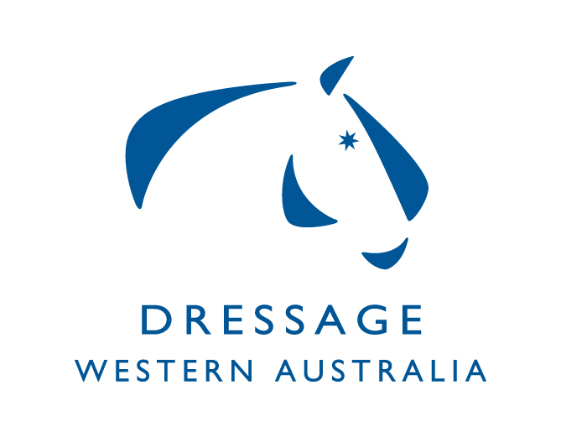
COMPETITION INCENTIVES FOR CLUBS
2021

Is your club eligible for a competition grant?
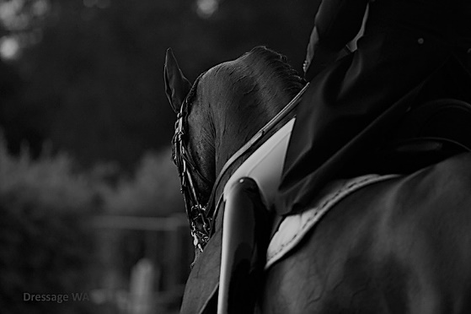
In 2021, Dressage WA is again offering EWA-affiliated clubs (including dressage and adult riding clubs) the opportunity to apply for retrospective subsidies when running official dressage competitions (Participant and Competitive).
The aim of this subsidy program is to encourage clubs to hold competitions and help them meet associated costs, such as venue hire, judges, officials and prizes.
Your club could be eligible for up to $1,120 for a first event, depending on the level of classes offered and the number of tests ridden and scored. It is important to note that the subsidy is only offered for two events per club per calendar year and they must be run under and comply with EA rules.
Supporting lower fees for competitors
Following feedback from riders about the increasing costs associated with competing, Dressage WA is continuing to apply a maximum charge of $35 per test (+$10 for FEI) for any events it runs in 2021 (excluding the State Dressage Championships).
To be eligible for a DWA competition subsidy, organising clubs and committees are required to:
- cap their test fees at the same level (no exceptions apply). This does not include any applicable Ground Service Fees.
- Use Nominate for entries
The table below summarises the subsidies available and the relevant eligibility criteria:
Subsidy per event | Eligibility criteria
$150 for 1st event  $300 for 2nd event  $175 for 1st event  $350 for 2nd event  $200 for 1st event  $400 for 2nd event | Minimum 30 Participant and Competitive tests (Preparatory to Advanced) ridden and scored  Minimum 40 Participant and Competitive tests (Preparatory to Advanced) ridden and scored  Minimum of 50 Participant and Competitive tests (Preparatory to Advanced) ridden & scored
$120 | Minimum of 3 Small Tour (PSG and Inter 1) tests ridden & scored
$120 | Minimum of 3 Medium Tour (Inter A and B) or Large Tour (Inter II and GP) tests ridden & scored
$120 | Minimum of 3 FEI young horse/pony tests ridden & scored
$40 per test to max of $120 | For up to 3 PE tests ridden & scored (no subsidy for further tests)
$40 per test to max of $120 | For up to 3 FEI PE tests ridden & scored (no subsidy for further tests)
$120 | Minimum of 3 young horse/pony tests (4, 5 and 6 year-olds) ridden & scored
$200 | Minimum of 5 freestyles ridden & scored

How to apply?
After your competition, please send an application letter to DWA using the Contact form on our website at www.dressagewa.org. This letter should include your club details, competition summary and club’s banking information.
Please note, applications must be received within 3 months of the competition to be considered.
You must also include the following supporting information to be considered for a subsidy (no exceptions apply):
- Copy of the competition schedule, including fees
- Copy of the final results, including scores/placings
- Competition report and photos (in electronic format) for the DWA newsletter
Recommendation:
To encourage more spectators, we recommend competition draw to be advertised on Club Facebook Page and Club Website prior to competition.
Competition results to be advertised on Club Facebook Page or Club Website.
Where does this funding come from?
These subsidies are provided through the Dressage Development Fund, which collects the levies applied to Participant, Competitive and Restricted dressage tests. Dressage WA has responsibility for administering this fund and reinvesting the levies into initiatives that encourage further participation and growth in the sport.

For more information
Please Contact DWA’s Representative: Paula Zammit

Email: paula.zammit01@gmail.com
Web: www.dressagewa.org

