August 2012 News Sheet

for Dressage Judges

www.dressagewa.org

The weather was perfect for the Dressage Education Seminar in July, and 34 judges, trainee judges, riders and coaches participated. Thanks to Jacqui Moon and PCAWA for accommodating everyone for the theory session, and to the demonstration riders who gave everyone the opportunity for discussion on many many aspects of our wonderful sport - Dressage. A question that was raised at the end of the Seminar is discussed over the page.

Thank you to the many people who gave a hand at the 3 evenings of Helping Hand Dressage on Fridays at SEC, we really appreciated your contribution that helped to make all the events a success.

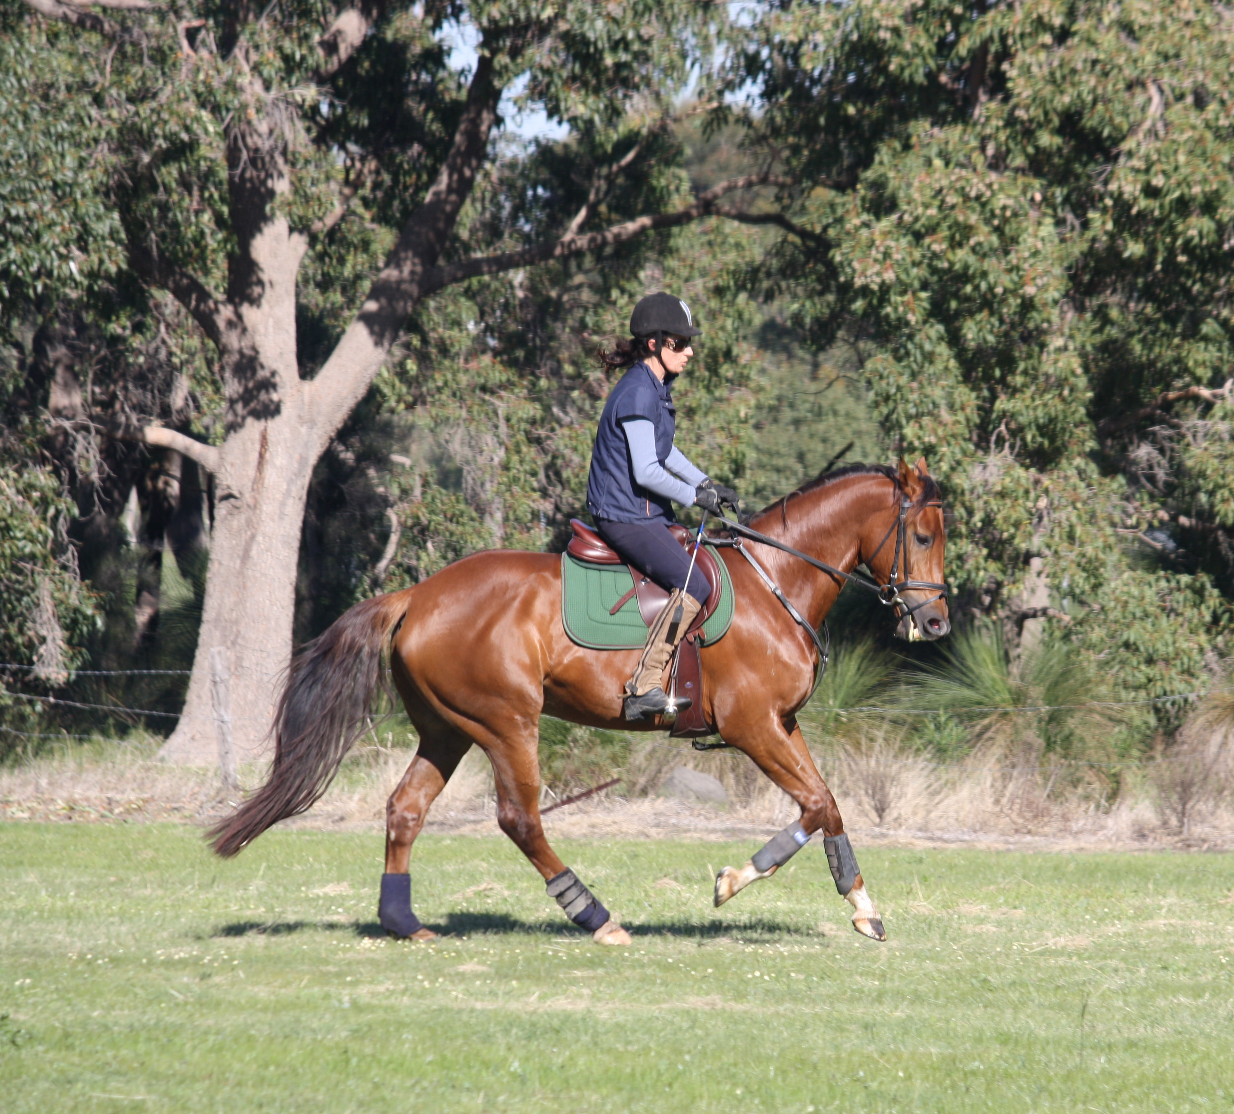

The Guinot Spring Dressage Festival is on 8-9th September.
Judges please keep a day free in your diary to judge over this important weekend in WA’s Dressage calendar.

Upcoming Dressage Education Seminars – more details soon

A & B (& C?) Level Dressage Education Seminar with Ginny Creed Saturday 29 September

Freestyle Dressage Education Seminar with Ginny Creed Sunday 30 September

An evening with Jennie Loristen-Clarke – Tuesday 23 October - we hope to confirm this very soon.

Becoming a judge
If you need information on how to become a judge, go to www.dressagewa.org

Writing, Mentoring & Sitting in Opportunities
There will be opportunities to write for the three Guest Judges who are travelling to WA for the Guinot Spring Dressage Festival. This is a great way to learn more about judging, and to develop your eye.

Draws will be up on www.dressagewa.org listing judges at most events. A current list of Mentors and Judge Educators is now available on this site under www.dressagewa.org/Dressage Judge Contacts
Generally speaking, the best way to arrange mentoring and sitting in is to check the Draw then contact the appropriate Mentor using the Judge Contact list on DWA’s website to request the opportunity personally.
Freestyle - Degree of Difficulty (DoD) = well-calculated risk

In Freestyle, at all levels, there are compulsory movements – listed on the Freestyle Sheet, and there are permitted movements – those that are not compulsory, but which a rider can use to augment their test (see Chart 6.8 in the EA Rule Book). At the Seminar in July, a question was raised about including more difficult movements in a Freestyle Test. A rider had been advised not to include movements with a higher DoD than was listed (compulsory) in a test.

It goes without saying that DoD will only be rewarded if it comes off well technically – then the rider has made a well-calculated risk. If the horse does not work well, it cannot be judged to be well-calculated risk, and in a worst case scenario, may affect the Technical Marks as well as the Artistic Marks. With regard to non-compulsory movements, it is advisable for riders to only include those that they are confident they will do well.

The Choreography Mark can be enhanced through interesting and inventive execution. In a Freestyle where a higher DoD is executed well, the Choreography Mark may also be high. In tests where there is no DoD, movements performed beyond the listed requirements, (including more difficult movements that are permitted at that level) may well improve the Choreography Mark.

In Preliminary and Novice Freestyle there are no marks for DoD, and in Para Equestrian Freestyle, the DoD mark has also now been removed. Notwithstanding this, in FEI PE Dressage, the best tests at international level will almost always incorporate a high DoD. When the field is strong, in order to place in the field, most FEI PE riders will perform movements well beyond the minimum requirements, including more difficult movements permitted at that level, to maximise their points in Choreography.

In FEI PE Grade IV riders will perform extended canter to half canter pirouettes, five x four time and five x three time flying changes, trot and canter zig zags in half pass etc. At 2* and 3* international PE events, virtually every rider will show permitted movements that are not compulsory. While there is no DoD in Preliminary and Novice Freestyle, combinations who can perform more difficult (permitted) exercises well technically to create highlights, are likely to be rewarded in the Choreography Mark.

Best wishes

Wendy Barker

